Name : Moemen Shaban El-Shazly
- New Customer

TC_004

TC_005
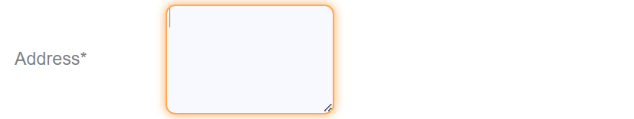

TC_006
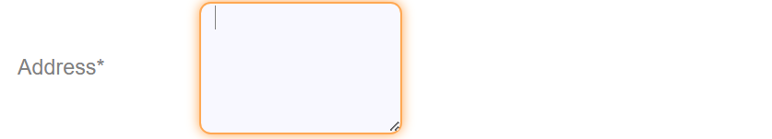

TC_007
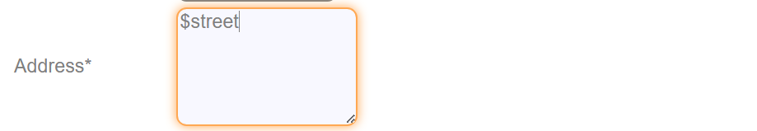

TC_011

TC_015

TC_020

TC_021

TC_024

TC_027

- Customized Statement Form

TC_031

TC_032

TC_033

TC_034

TC_035

TC_036

- Delete Customer

TC_043

- Edit Customer form

TC_050

